**Increasing Loads Threads:**

As taken to test the login page ..we given load threads of 3..its going to execute the script for 3 times by ramp up of 2 secs.

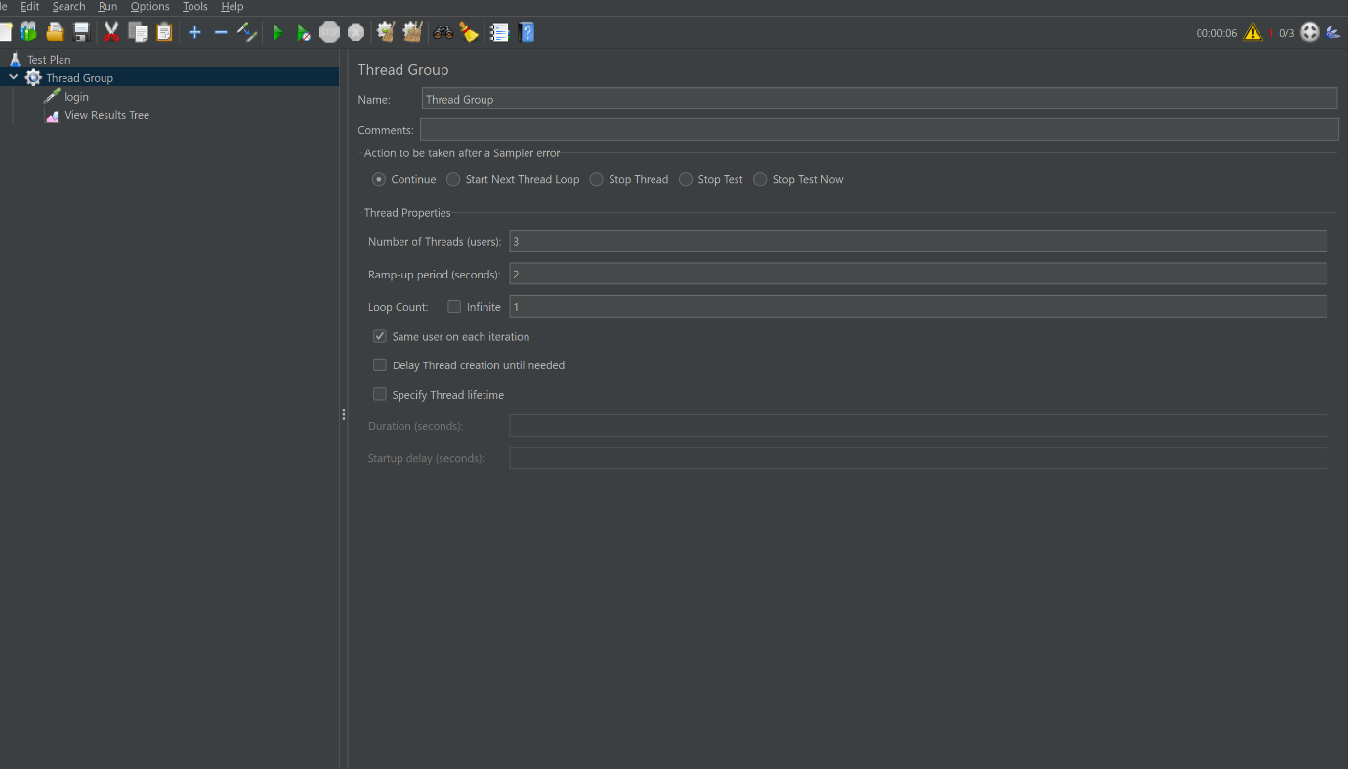

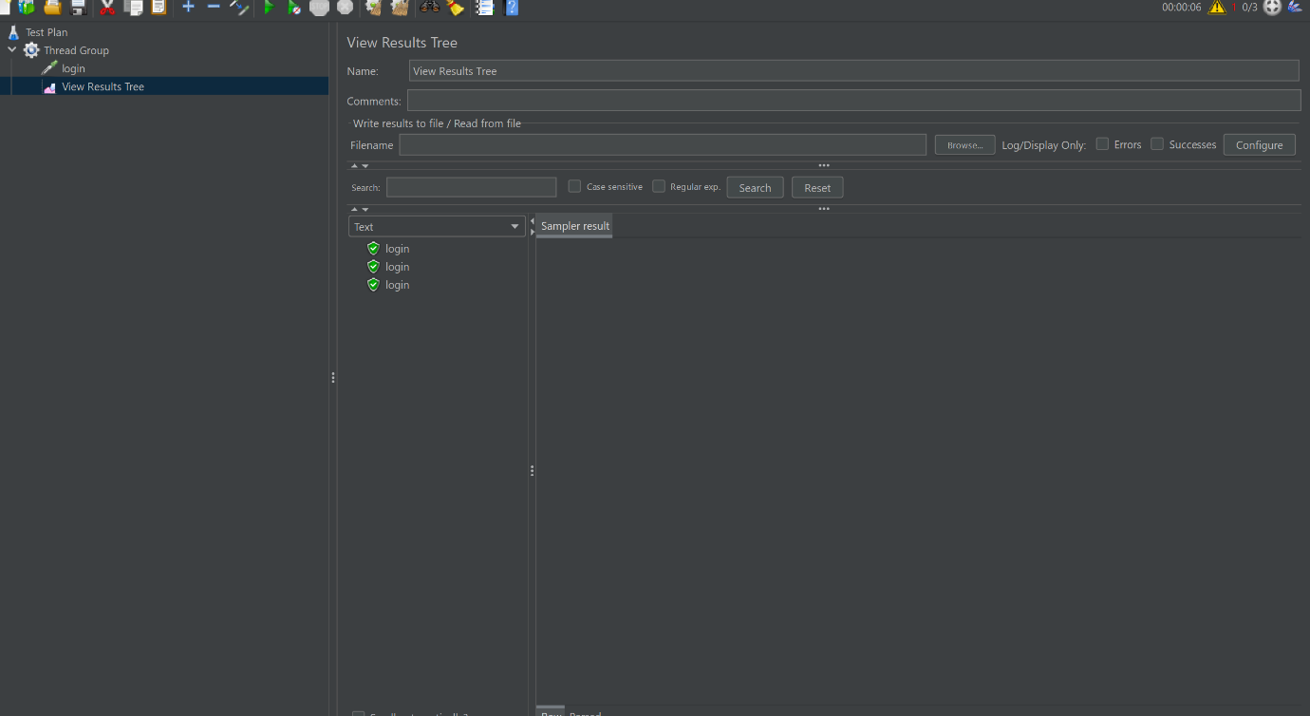

As now load I increased to no .of threads is 10, Ramp up =2 , loop =2;

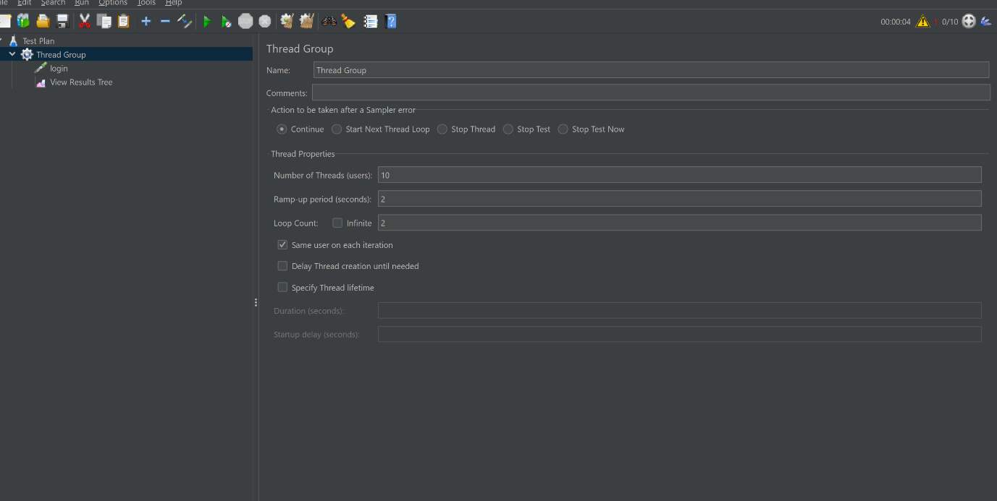

Load increased while ramp up and loop and threads count increases.

